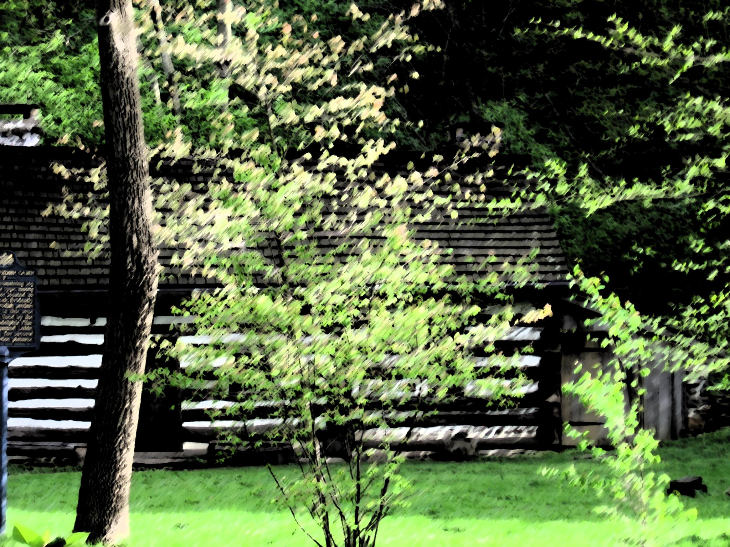
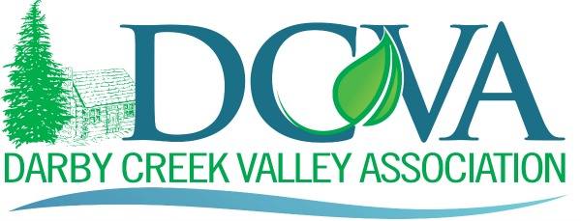
DARBY CREEK VALLEY ASSOCIATION 37th ANNUAL MEETING
Saturday, March 4th, 2023
Face-to-Face &Virtual Meeting via Zoom
Jaclyn Rhoads, President, presiding

ANNUAL MEETING AGENDA
Time Program Agenda
9:00 – 9:30 Call to Order, Pledge of Allegiance, Invocation, - Jaclyn Rhoads
2022 End-of-Year Summary & Annual Meeting Introduction – Jaclyn Rhoads
Presentations by Speakers
9:30 -10:00 Jaclyn Rhoads, John Heinz National Wildlife Refuge at Tinicum
Title: What’s Happening at the Heinz!
10:00 - 10:30 Rick Tralies, National Lands Trust; Senior Director of Landscape Planning
Title: The Darby Creek Resilience, Conservation and Management Plan
10:30 – 11:00 Jamie Singer and Joe MacNeal, Volunteers, Preserve Oakwell
Title: Save and Preserve Oakwell
11:00 – 11:15 Title: High School & Middle School Environmental Initiatives – clubs & classes
Haverford High School – Remy Dufresne & Kelly Murray
11:15 – 11:45 DCVA Blasts
- Stream Cleanup (Saturdays in April) – Aurora Dizel
- Stream Watch Program (April 8th) - Alan Samel
- Stream Smart - Jamie Anderson
- TAG – Jaclyn Rhoads
- Community Science Reporting – Lauren NcGrath/George Ambrose
- Growing Greener Rain Gardens – Peter Puglionese/Jamie Anderson
- Quadrangle Meadow Program- Terry Cooke
- Cobbs Creek Environmental Justice – Robin Mann (https://www.facebook.com/CobbsCreekEJ/videos/420132642946131)
11:45 - 12:00 Closing Remarks & Meeting Conclusion– Jaclyn Rhoads
12:00 – 1:00 Lunch – CREC Rushforth Environmental Laboratory

1:00 -2:30 Annual Membership Business Meeting - All are Welcome
- Approval of Minutes from February 26th, 2022: Jaclyn Rhoads
- Acceptance of Treasurer’s Report: Dick Carroll, Treasurer
- Governance Committee Update - Tim
- Ribbon of Green Award - Governance Committee
- Governance Committee Report and election of Board members:
- Welcome to new Board members and adjournment: Jaclyn
- Adjourn Annual Meeting: All

